BUSINESS INTELLIGENCE (INDIVIDUAL) REPORT

NAME: Mohammed Nisaruddin

Data Number: 21

Contents

EXECUTIVE SUMMARY 3

1. INTRODUCTION 4

2. DATA PREPARATION 4

3. GENDER PAY GAP ANALYSIS 5

4. GENDER EQUAL PAY ANALYSIS 9

5. CONCLUSION 12

6. RECOMMENDATIONS 12

# EXECUTIVE SUMMARY

Our firm prioritizes equal pay and fairness across genders, recognizing its crucial role in building and maintaining a healthy work environment. However, the recent analysis reveals interesting insights related to gender pay disparity that needs our attention. While female employees have slightly higher mean and median salaries as compare to male employees but other aspects represent a different picture.

The male employees received nearly 23% to 33% higher annual bonuses as compare to female employees which suggests a potential disparity in our bonus allocation. Similarly, males have higher proportion in all job positions as compare to females. In pay quartiles male also have higher representation particularly in the lowest and highest pay brackets.

According to these insights, our goal of gender equality seems to have only partially succeeded with certain areas required efforts and improvements. To rectify these disparities, it is recommended to review our bonus allocation process to identify and eliminate any bias against female employees. Certain steps must also be taken to promote gender balance across all job positions.

Finally, it is recommended to have regular pay audits to ensure continued compliance with gender pay gap legalization. The gender pay equality is not only limited to number and statistics, it’s about building a workplace culture that genuinely value diversity and equality. These proactive measures will strengthen our company’s reputation, contributing to a fairer and equitable workplace for all employees.

# INTRODUCTION

Gender pay inequality is one of the important issue in workplaces in whole world despite numerous attempts to rectify the situation. In the UK, the Equality Act 2010 seeks to ensure equal pay for equal work regardless of gender. Organizations in the UK, also have to produce gender pay reports in line with Gender Pay Gap Reporting Regulations.

In our firm, our top priority is to maintain the culture of equal pay and fairness in order to eradicate any instance of gender-based parity. Our firm believed in rewarding the employees based on their abilities and skills regardless of employee’s gender. The main goal of this project to assess our firm’s current gender pay status, identify and potential discrepancies and recommendations to rectify them.

Our firm want to fulfil our obligation under UK law by generating report based on six required indicators outlined by the UK Government. The analysis of gender pays gaps and then sharing them will help to promote transparency within our organization. This will also help to take necessary steps to ensure fairness and equal pay regardless of gender. The reputation of any organization heavily depends on its stance towards equality and inclusivity. By actively striving for gender pay parity, our goal is to build a positive image for our firm.

The main motive is to evaluate the current situation by analyzing the available data and then making informed decision and recommendations. The framework that will be used is UK legal requirements and best practice guidelines for gender equal pay.

# DATA PREPARATION

The table for variables in the data and their definitions is shown below:

Table 1: Variable Definitions

|  |  |
| --- | --- |
| Variable name | Variable values |
| Gender | Indicating the gender of the employee as male or female. |
| Tenure | The duration that the employee works in the firm in months. |
| FTE | The full-time equivalent of an employee’s contractual working hours, 1 stands for 100%, or full-time and all proportions below 1 represent the proportion of the contractual working hours, ex: 0.6 means 60% of the full-time working hours. A full-time employee works 40 hours a week. |
| Office | An indicator of the office to which the employee currently belongs to. |
| Salary | The monthly base salary of each employee in £. The base salary is negotiated at job entry. The salary rises annually with a factor bargained with the firm’s recognised union but can also rise because of individual negotiations of each employee. |
| Bonus | An annual bonus in £ based on the employee’s appraisal and the team performance last year. |
| Qualification | An indicator of the employee’s highest educational credential. |
| Position | An indicator of the position of the employee in a junior position, senior position or as an assistant to the manager. |
| pid | A person identifier from the HR records. |

N = 789

There were some issues in the data. There is a category “.” in position variable, the gender has two different values “Female” and “female” and also there is a diverse category in gender. All these problems are resolved to make the data clean and ready for analysis.

The summary statistics table for numerical variables is shown below: Table 2: Descriptive Statistics

|  |  |  |  |  |
| --- | --- | --- | --- | --- |
| Variable | Mean | Standard deviation | Min | Max |
| Office | 4.43 | 2.65 | 1 | 9 |
| Tenure | 91.43 | 43.16 | 2 | 256 |
| FTE | 0.91 | 0.15 | 0.5 | 1 |
| Salary | 1492.12 | 357.41 | 543 | 2647 |
| Bonus | 4736.66 | 1597.02 | 0 | 9410 |

# GENDER PAY GAP ANALYSIS

For data analysis, first of all we computed all six indicators for gender pay gap according to UK legal requirements.

Table 3: Mean Gender Pay Gap

|  |  |  |
| --- | --- | --- |
| Female | Male | Mean Pay Gap |
| 1562.3 | 1460.22 | -6.99 |

Table 4: Median Gender Pay Gap

|  |  |  |
| --- | --- | --- |
| Female | Male | Mean Pay Gap |
| 1586.9 | 1515 | -4.75 |

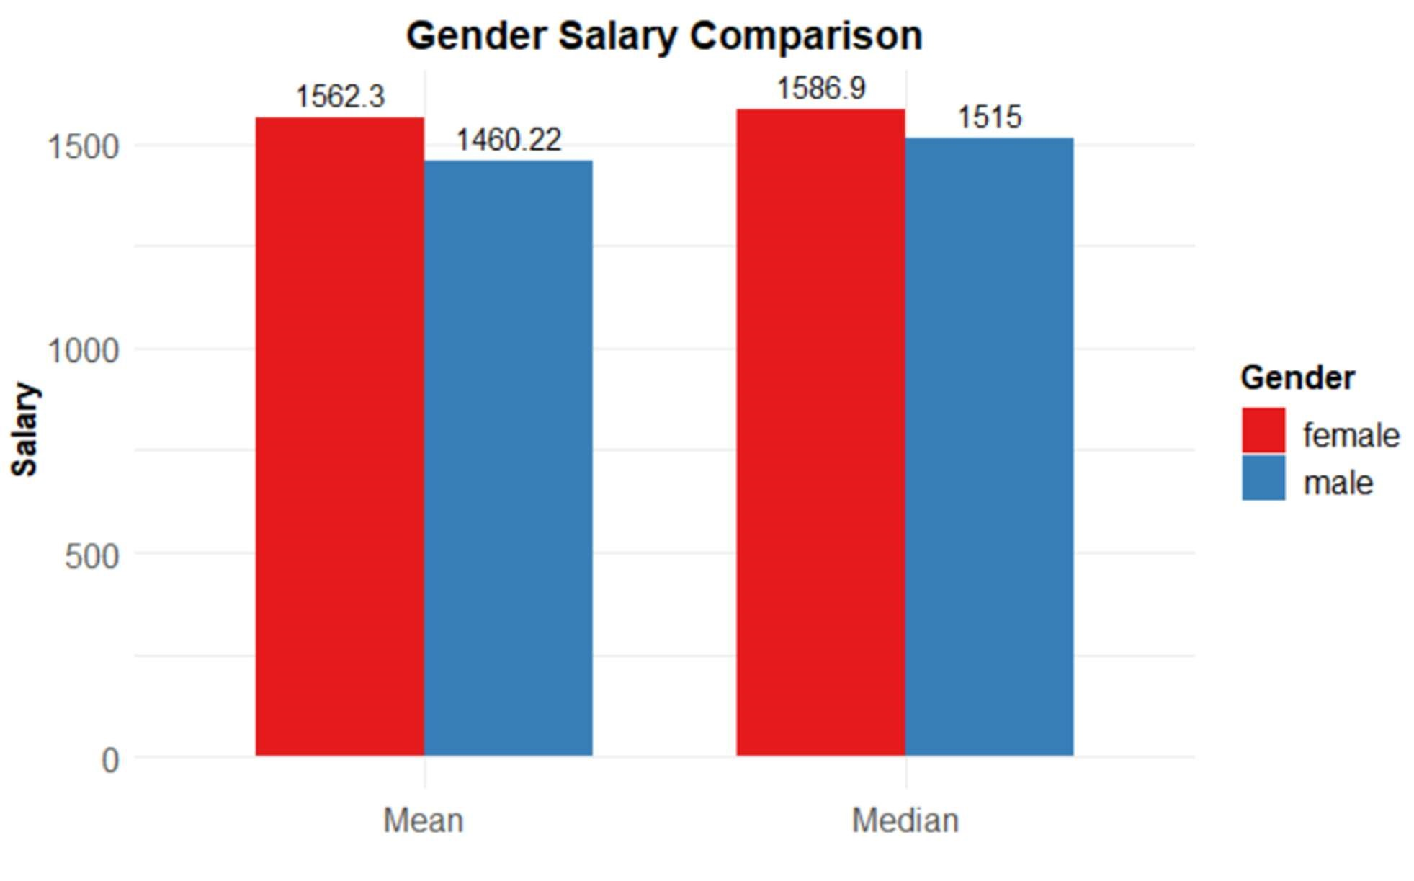

Figure 1: Gender Salary Comparison

The analysis indicates that the mean salary for male employees is £1460.22 and for female employees is £1562.3, resulting in a mean gender pay gap of -6.99. The median salaries are £1515 for males and £1586.9 for females, with a median gender pay gap of -4.75. This is unexpected as male usually earn more than female. But this does not mean that there is no issue of gender inequality in the organization.

Table 3: Mean Gender Bonus Gap

|  |  |  |
| --- | --- | --- |
| Female | Male | Mean Bonus Gap |
| 3936.76 | 5100.11 | 22.81 |

Table 4: Median Gender Bonus Gap

|  |  |  |
| --- | --- | --- |
| Female | Male | Mean Bonus Gap |
| 3510 | 5270 | 33.40 |

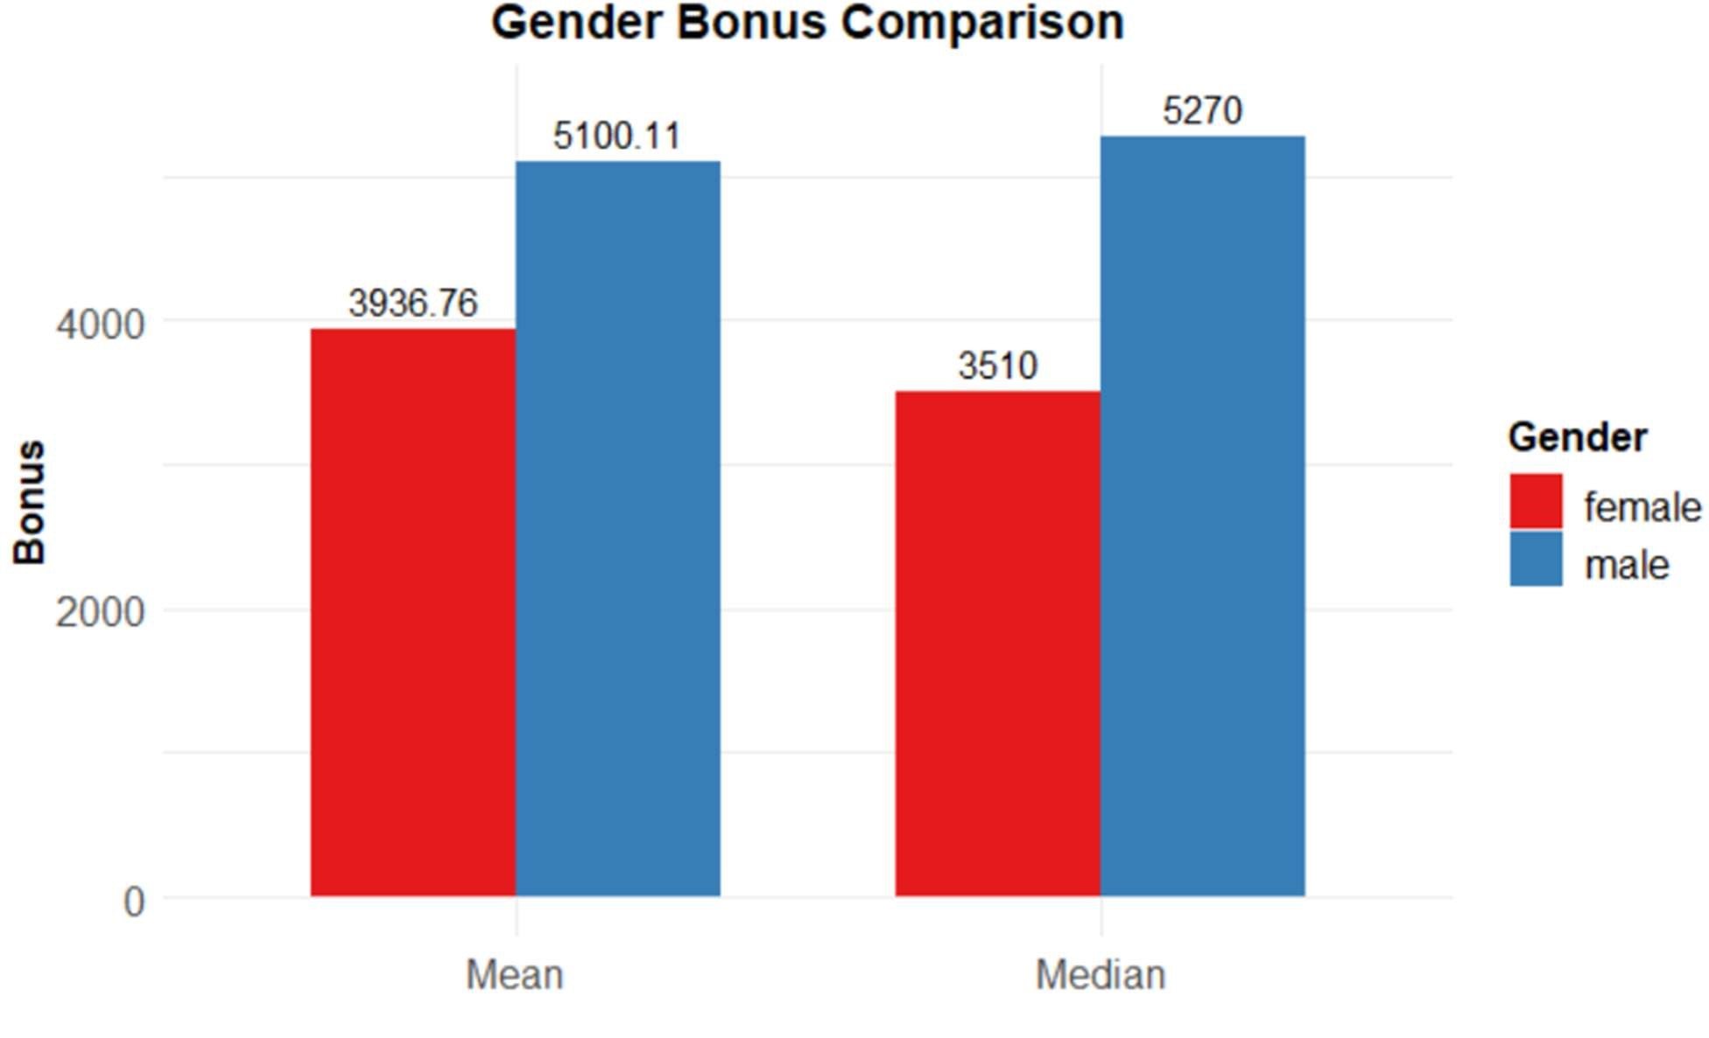

Figure 2: Gender Bonus Comparison

The data indicates that the mean and median annual bonuses for male employees are £5100.11 and £5270 respectively, higher than the female employees' mean and median bonuses of £3936.76 and £3510. The bonus gaps are 22.81% and 33.4% at the mean and median respectively, showing that men receive significantly larger bonuses than women. This reveals a potential inequality in the company's reward structure.

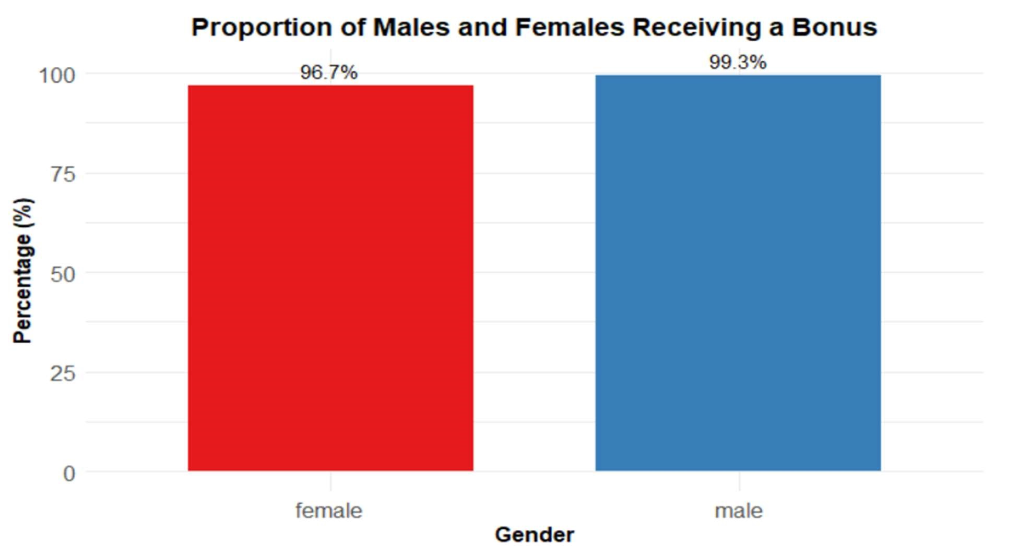

Figure 3: Proportion of Males and Females Receiving a Bonus

The above plot shows that 96.7% of female employees received bonuses and 99.3% of male employees received bonuses. This suggest that the proportion of male employees who received bonus is slightly higher.

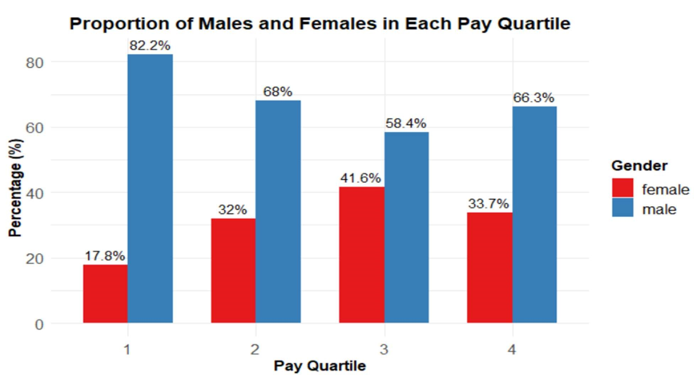

Figure 4: Proportion of Males and Females in Each Pay Quartile

The above plot shows that there is a gender disparity across pay quartiles. In first quartile there are 82.8% male employees and 17.8% female employees. The plot shows that in all pay quartiles there are higher male employees as compare to female employees.

# GENDER EQUAL PAY ANALYSIS

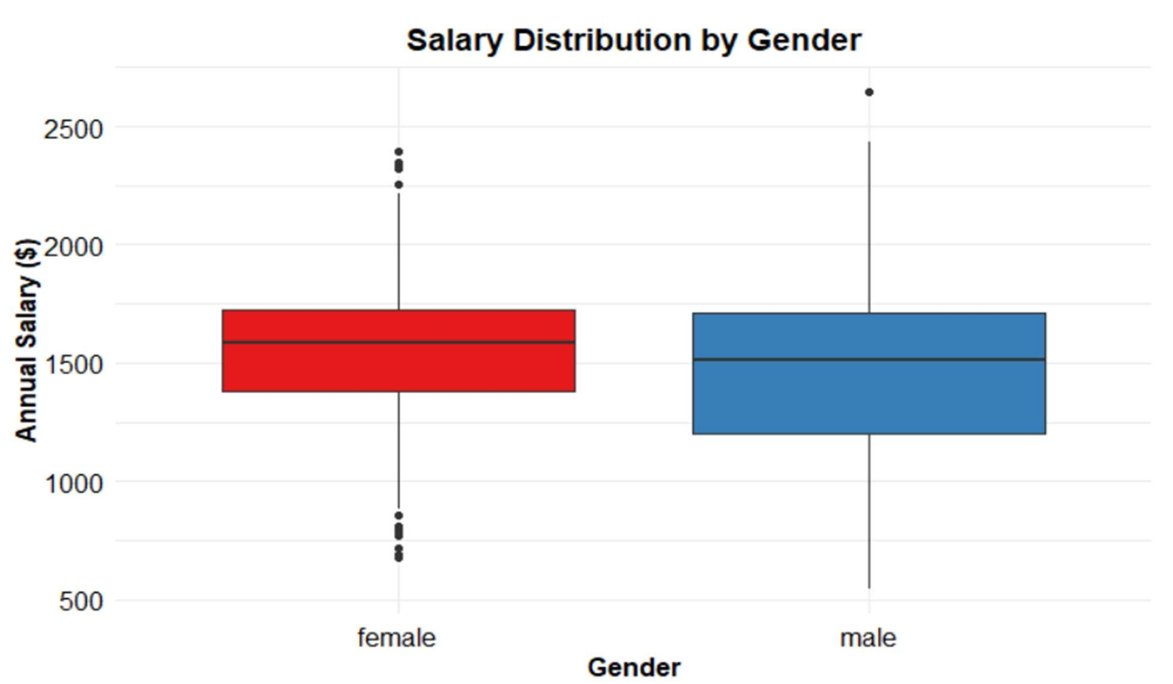

Figure 5: Salary Distribution by Gender

The above plot shows that the median salary for male employees is lower than for females but there is a higher variation in male salaries as compared to female employees and there are some outliers.

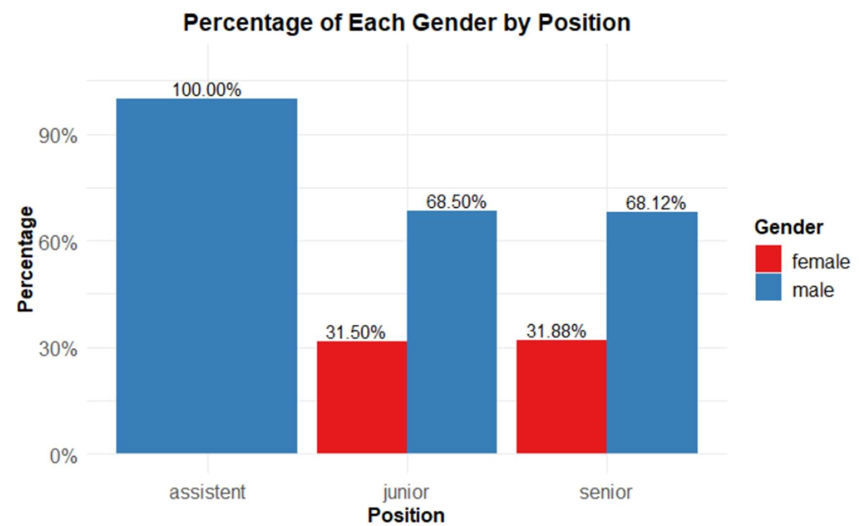

Figure 6: Percentage of Each Gender by Position

The plot shows that all the assistant positions are held by male’s employees and almost 68% of employees in junior and senior positions are also males.

Table 5. Multiple Regression of Employee Salary

|  |  |  |  |  |
| --- | --- | --- | --- | --- |
| Variable | Model1 | Model2 | Model3 | Model4 |
|  | Coef. (p-value) | Coef. (p-value) | Coef. (p-value) | Coef. (p-value) |
| Gender Male | -102.08 (0.00) | -115.34 (0.00) | -88.53 (0.00) | -10.5.77 (0.00) |
| Qualification  BA/BSC |  |  |  | 14.54 (0.59) |
| Qualification  MA/MSC |  |  |  | 63.37 (0.20) |
| Position Junior |  | 18.60 (0.90) |  | 34.017 (0.81) |
| Position Senior |  | 161.56 (0.27) |  | 172.55 (0.21) |
| Tenure |  | 1.39 (0.00) |  | 1.38 (0.00) |
| Office 2 |  |  | -22.35 (0.64) | -25.80 (0.58) |
| Office 3 |  |  | 13. 37 (0.78) | -7.18 (0.88) |
| Office 4 |  |  | -45.02 (0.29) | -56.83 (0.18) |
| Office 5 |  |  | 24.90 (0.63) | 4.24 (0.93) |
| Office 6 |  |  | 47.59 (0.33) | 9.51 (0.85) |
| Office 9 |  |  | 77.37 (0.08) | 54.84 (0.21) |
| N | 787 | 787 | 787 | 787 |
| R-square | 0.0163 | 0.06591 | 0.02253 | 0.06878 |

Method OLS: Dependent Variable Salary

The table5 shows model 4 with predictors qualification, position, tenure and office has higher Rsquared value. The variable tenure has significant relationship with employee salary in that model. The coefficient value for tenure suggests that one-unit increase in tenure is associated with 1.38-unit increase in employee salary. For first model, the gender variable has significant relationship with employee salary, the coefficient value suggest that women have £102.08. In second model predictors gender and tenure have significant relationship with dependent variable salary. The coefficient value for gender suggests that female employees have £115.34 higher salary compared to male employees. The coefficient value for tenure suggest that oneunit increase in tenure is associated with £1.39-unit increase in salary. In third model, only gender has significant relationship with employee salary. The coefficient value suggests female employees have £88.53 higher salary compared to male employees.

Table 6. Multiple Regression of Employee Bonus

|  |  |  |  |  |
| --- | --- | --- | --- | --- |
| Variable | Model1 | Model2 | Model3 | Model4 |
|  | Coef. (p-value) | Coef. (p-value) | Coef. (p-value) | Coef. (p-value) |
| Gender Male | 1163.35 (0.00) | 1165.4 (0.00) | 1027.7 (0.00) | 995.58 (0.00) |
| Qualification  BA/BSC |  | 363.8 (0.00) |  | 398.91 (0.00) |
| Qualification  MA/MSC |  | 256.6 (0.21) |  | 294.703 (0.08) |
| Position Junior |  | -1552.6 (0.01) |  | -382.08 (0.44) |
| Position Senior |  | -839.2 (0.18) |  | 33.457 (0.94) |
| Tenure |  |  |  | 1.38 (0.00) |
| Office 2 |  |  | 748.2 (0.00) | -743.187 (0.00) |
| Office 3 |  |  | 983.9 (0.00) | 950.862 (0.00) |
| Office 4 |  |  | 532.8 (0.00) | 518.347 (0.00) |
| Office 5 |  |  | 1200.7 (0.00) | 1151.57 (0.00) |
| Office 6 |  |  | 1748.1 (0.00) | 1652.62 (0.00) |
| Office 9 |  |  | -1118.7 (0.00) | -1153.50 0.00 |
| N | 787 | 787 | 787 | 787 |
| R-square | 0.113 | 0.148 | 0.4185 | 0.4481 |

The fourth model with predictors qualification, gender, position tenure and office has highest Rsquared value. The predictors gender, qualification, tenure and office have significant relationship with employee bonus. The coefficient for gender suggest that male employees have £995.58 higher bonus as compare to female employees. Employees with qualification BA/BSC have £398.91 higher bonus and employees with qualification MA/MSC have £294.7 higher salary as compare to employees with qualification Apprenticeship/ some college. One-unit increase in tenure is associated with £1.38-unit increase in bonus.

# CONCLUSION

The analysis indicates that even the average median and mean salaries for female employees are higher as compared to male which is unexpected but still an indication of gender inequality within the firm. On the other hand, the analysis discovers significant disparities in the distribution of bonuses where male employees earn larger bonuses compared to female employees. Male employees also seem to domination the proportion across all quartiles of pay specifically in lowest and highest pay bracket. Also the proportion of males in all job positions (Assistant, Junior, Senior) is significantly higher than females. Despite the slightly higher women salaries, these insights suggest that there is a gender disparity within the firm, particularly in bonus collection and job position distributions. This suggest that the firm may have achieved some sort of gender pay equality but there are still areas that require retention and improvement to achieve comprehensive gender inequality.

# RECOMMENDATIONS

The following recommendations can be made based on this analysis:

* Since the analysis revealed significant disparities in bonus allocation between genders, it is recommended to review, and check is there any factor in bonus allocation process that may unintentionally disadvantage women?
* Given the underrepresentation of women in all positions, steps should be taken to encourage more balanced gender representation in all positions.
* It is recommended to have regular pay audits, to ensure continued compliance with gender pay gap legalization and maintain transparency within the organization.
* Gender pay equality goes beyond number and statistics, it is important to build and maintain a culture in workplace that values diversity and equality.